students say:
“I like it that if I speak out and it isn’t the answer you are looking for, you don’t make me feel stupid.”
“Work is not ordinary school work. It’s like learning without the work though we are working.”
“I like the diversity and group participation in the class.”
“There was always someone to help. The instructors all would make sure you knew what you were doing.”
“I learned a whole lot more than I do in a stand-alone class.”
“I understood more things when I worked with others.”

CALL
(520) 357-7864



Central Arizona College

Aravaipa Campus
80440 E. Aravaipa Rd.
Winkelman, AZ 85292
Phone: (520) 357-7864
(520) 487-2351
www.geocities.com/lcomavc

Join The Aravaipa Learning Community

Coming Together Where the Waters Meet
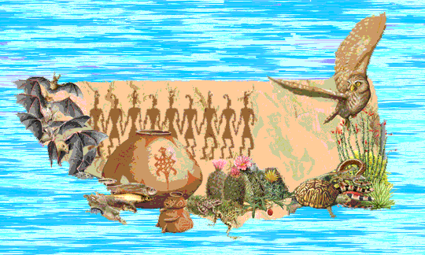

Join the

Aravaipa

Learning Community

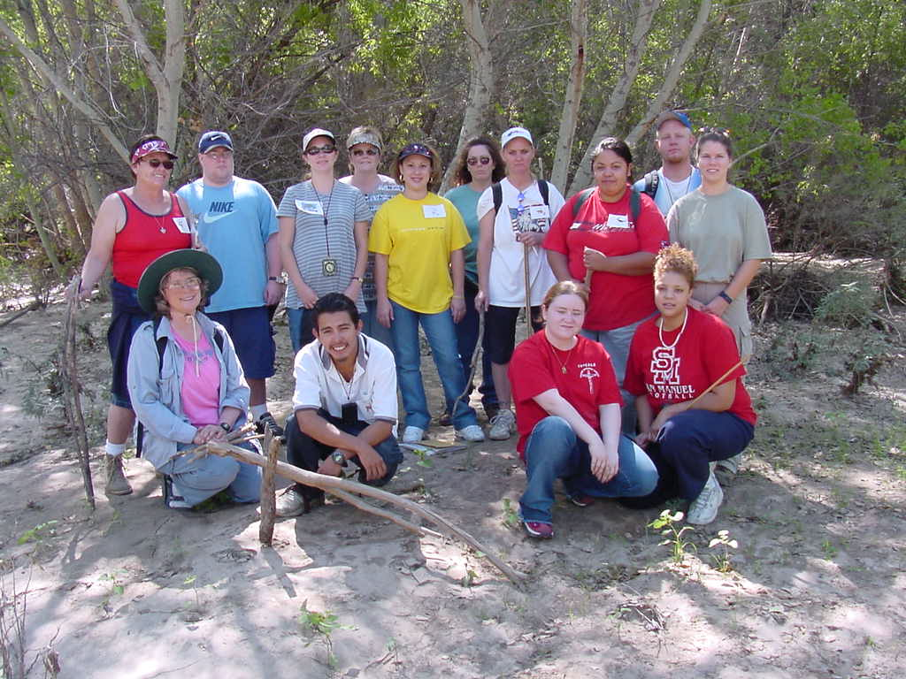

the way research shows people learn best
Participate in your own learning,.
Discover connections between subjects.
Experience hands-on applications.
Make friends and study together in groups.
Meet your neighbors and learn about community history and environment.

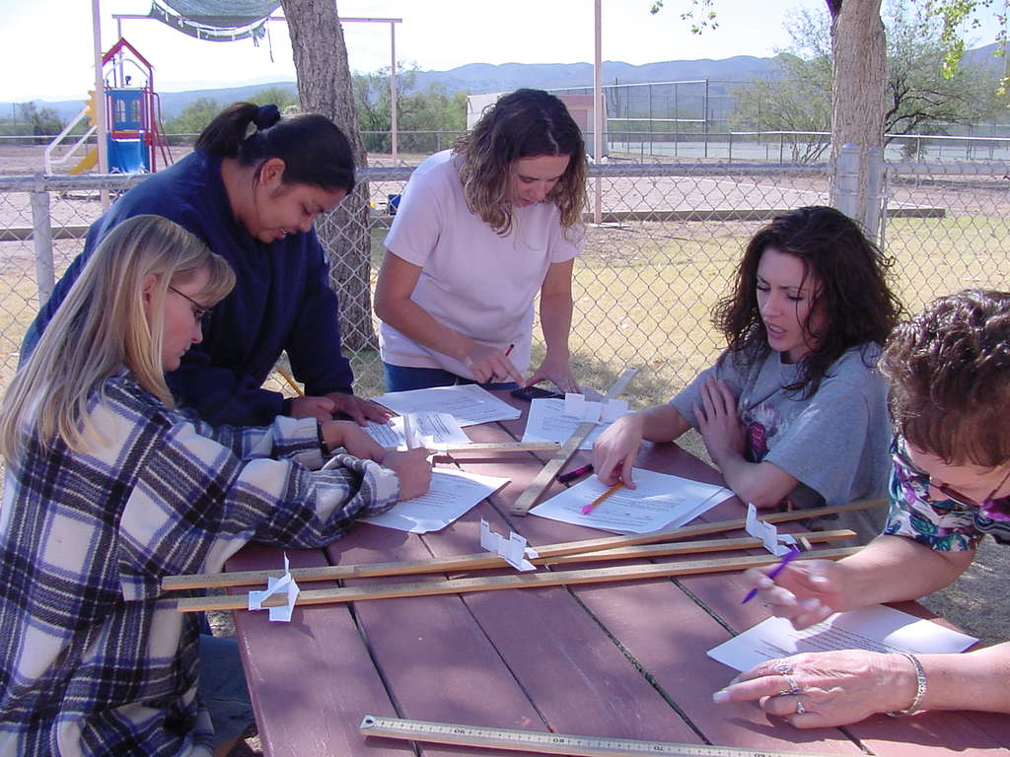

how does it work?
Earn 13 credit hours through activities and hands-on experiences. 3 credits social science, 3 credits computer science or 3 credits study skills and 4 credits math and 3 credits English.
Grades based on activities, including field trips, films, guest speakers, and simulations.
Convenient schedule. Only two days each week.
This class replaces assessment testing.
Career and counseling services.
Three friendly, experienced teachers in the classroom to help you succeed.

Visit our Web Page at
www.geocities.com/lcomavc

activities make learning fun and interesting
Explore our community through learning activities. Some of our activities include archeological dating, surveying local plant life along the San Pedro River, visiting Indian ruins, and playing the FishBanks ecological simulation game. .
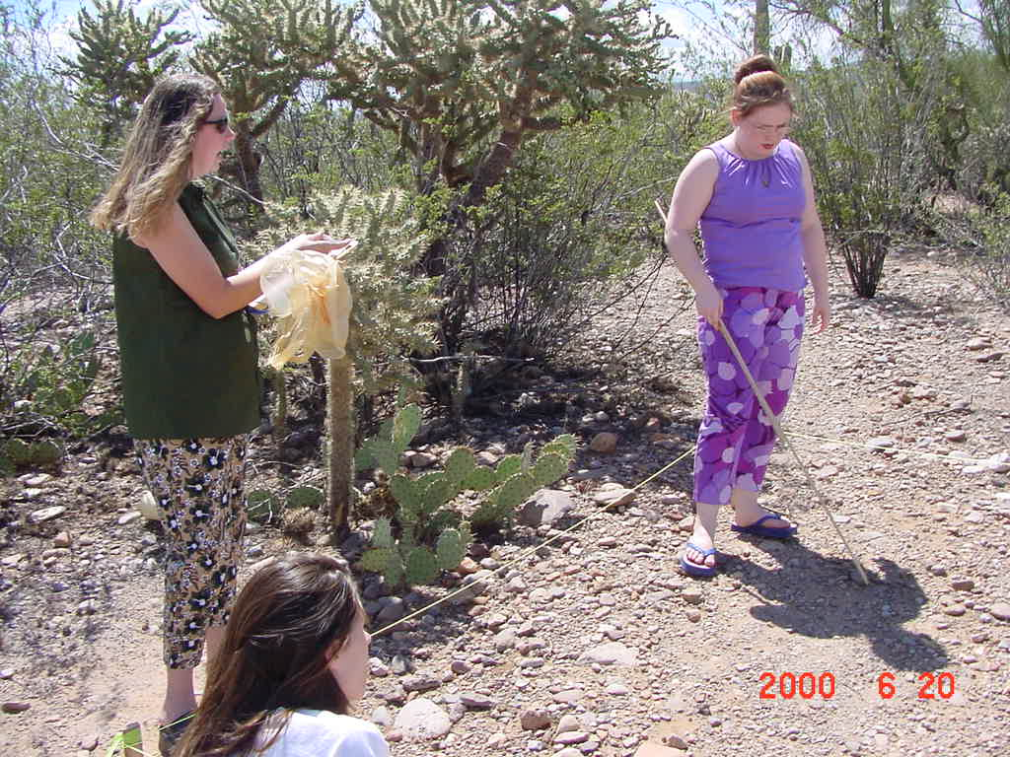

getting started
Fall 2003 Semester: Register for ARH 200; CIS120 or CPD101; MAT081, MAT091, or MAT121; and ENG090, ENG100 or ENG101
Instructors are Shay Cardell, Matthew Cornett and Maren Wilson

